Audit and Risk Committee
Independent Member
Information Pack - 2025
May 2025

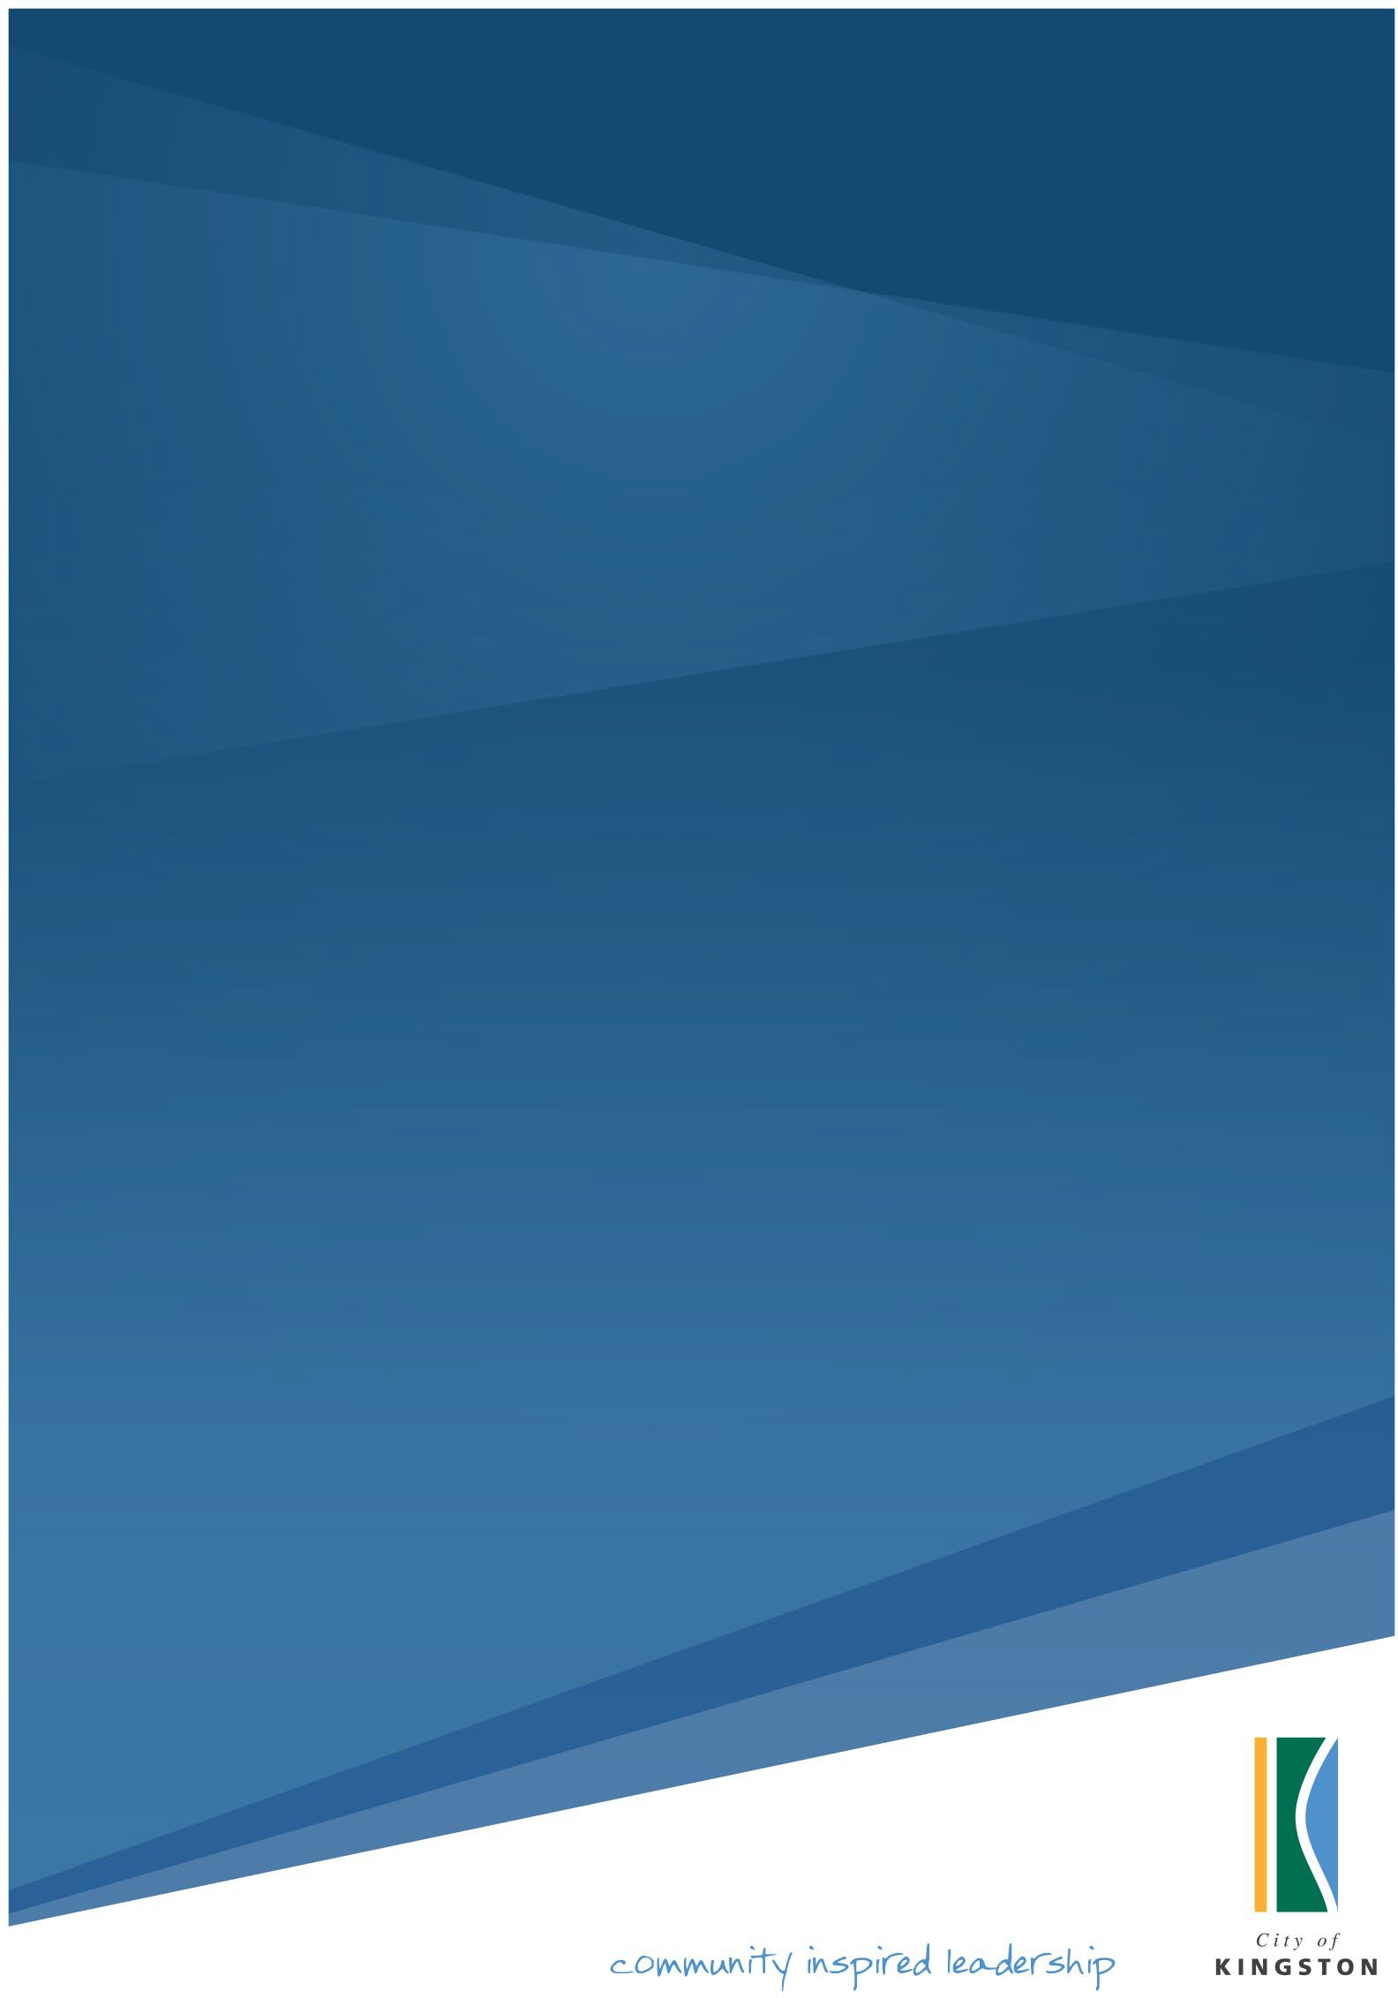

Role Description: Audit and Risk Committee Independent Member

Overview
Council is seeking to appoint an independent member to its Audit and Risk Committee for a period of three years. The Audit and Risk Committee comprises three independent members and two Councillors, all of whom have full voting rights.

The independent member will ideally have broad senior: business, corporate governance, audit, risk and/or financial reporting/management knowledge and experience. Applicants must also be able to demonstrate the ability to apply appropriate analytical and strategic management skills to matters that are within the Audit and Risk Committee Charter. Formal qualifications and previous audit committee or board experience will be highly regarded.

Remuneration by way of an annual fee is determined by Council and will be paid to independent members and indexed annually by the Melbourne All Groups CPI adjusted annually on 1 July.

Background

Kingston City Council’s Audit and Risk Committee is an independent Advisory Committee to Council that was first established in 1996. The primary objective of the Audit and Risk Committee is to assist Council in the effective conduct of its responsibilities for its management of risks, effectiveness of internal controls, financial reporting and monitoring overall governance practices.

The Audit and Risk Committee also has oversight of the internal audit function and the external auditor to facilitate achieving overall organisational objectives in an efficient and effective manner.

The Audit and Risk Committee Charter was last adopted by Council in August 2024 and is subject to annual review. The Charter specifies the functions and responsibilities of the Audit and Risk Committee as required by the Local Government Act 2020.

Selection Criteria
The Charter sets out the following selection criteria for candidates regarding Independent Members:
- Financial analytical / management skills
- Knowledge of Audit, Risk and Governance Frameworks
- Experience in public sector management
- Demonstrated strategic skills including, but not limited to:
- financial acumen
- information technology
- governance standards
- risk management.

Consideration will also be given to the collective experience and expertise of the independence members in the above criteria. Experience in public sector management involving capital delivery and risk will be highly regarded.

Eligibility Requirements

To be eligible to be an independent member of the City of Kingston’s Audit and Risk Committee, the individual must be free from any conflict of interest or any business or other relationship that could reasonably be perceived to interfere with the member’s ability to act in the best interests of Council. These conflicts of interests refer to (but are not limited to) commitments and provision of paid services to the Kingston City Council.

Being a ratepayer of the Kingston City Council does not of itself constitute a conflict of interest for an individual.

Anticipated Time Commitment

The Audit Committee normally meets four times per annum and holds quarterly meetings (March, June, September and December).

It is anticipated that the demand for individual members will be approximately 8 to 10 hours per meeting cycle. This will comprise meeting preparation, attendance at Audit and Risk Committee meetings and other input as required.

Scope and Responsibilities

- Actively and constructively contribute towards the Audit and Risk Committee’s performance through the provision of professional, independent and objective advice in respect of the delivery of the Audit and Risk Committee Charter
- Review complex financial and performance reports, statements
- Recommend the adoption of the annual financial report and annual performance statement to the Council
- Provide independent oversight on internal audit, external audit, governance and risk management plans, and other reports as required
- Provide objective advice on Council’s processes, procedures and internal control mechanisms
- Provide analysis and constructive comment on particular projects, reports, briefings, options or issues papers as required
- Adequately prepare for and attend all Council Audit and Risk Committee meetings

Kingston Council - Municipal Profile

OUR LOCATION
The City of Kingston is located approximately 20 km south-east of Melbourne, surrounded by the cities of Bayside, Glen Eira, Monash, Greater Dandenong and Frankston. The City’s landmarks are diverse and distinct. The area, known for its ‘village-like’ neighbourhoods, offers a relaxed lifestyle. Spanning 91 square kilometres with 13 kilometres of foreshore along Port Phillip Bay, it includes natural wetlands, historic market garden districts and numerous world-class golf courses. The community’s prosperity is underpinned by the Moorabbin and Braeside manufacturing areas, vital shopping precincts, access to beautiful open spaces and an enviable choice of quality schools and tertiary institutions. This has attracted housing development and population growth, particularly in and around our activity centres, key renewal areas, transportation hubs and more popular coastal suburbs. Kingston’s suburbs include Aspendale, Aspendale Gardens, Bonbeach, Braeside, Carrum, Chelsea, Chelsea Heights, Cheltenham, Clarinda, Clayton South, Dingley Village, Edithvale, Heatherton, Highett, Mentone, Moorabbin, Moorabbin Airport, Mordialloc, Oakleigh South, Parkdale, Patterson Lakes and Waterways.

COUNCIL WARDS
The City of Kingston is divided into 11 wards, with each of the wards represented by a single Councillor. The 11 elected Councillors make up Kingston City Council, and it is this group that represents the interests of residents and ratepayers. Our Councillors work together with the community and CEO Peter Bean to set our city’s strategic direction.

OUR GROWING POPULATION
Kingston’s estimated population exceeds 160,000 people. Approximately 24% of our residents are aged over 60 – this is more than the Greater Melbourne average. Our ageing population is more evident in suburbs of Kingston including Cheltenham, Dingley Village, Mentone, and Parkdale. Suburbs such as Edithvale and Bonbeach are experiencing a resurgence in primary school-aged children. Clayton South has a high proportion of young adults, consistent with its proximity to Monash University.
Overall, Kingston has a high proportion of people born in Australia (higher than the Greater Melbourne average) however, a large percentage of residents in the northern suburbs of Clayton South and Clarinda were born overseas and speak a language other than English at home. Some key statistics include:
• 65% people born in Australia;
• 26% of people speak a language other than English at home;
• Dominant birthplaces are UK, India, China and Greece.

COMMUNITY AND OUR SERVICES
Council provides over 120 services to its municipal community. This video provides an engaging overview - 120 Services.

